**Shivam Navnath Giri  
CDAC SILCHAR PGDAI**

**Git Submission 1**

**ASSIGNMENT**

**GIT COMMANDS**

**SUBMIT VIA SCREENSHOT OF YOUR CMD**

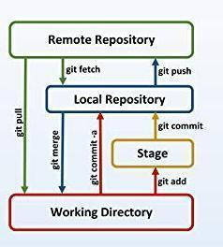

Q. Create a local git repository in your local machine first.

Commit the initial code

Q. Update the code on the remote server . Also perform some changes on remote n reflect the same on local.[push/pull operations]

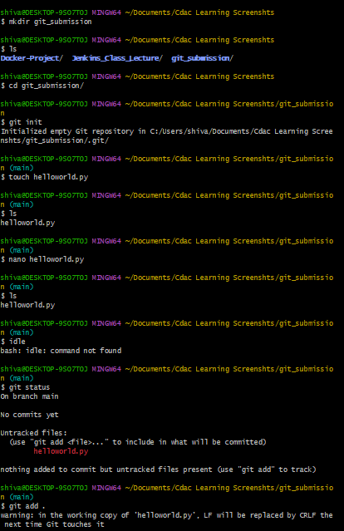

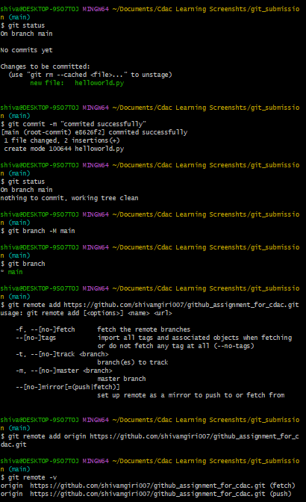

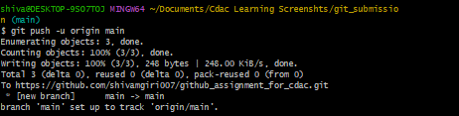

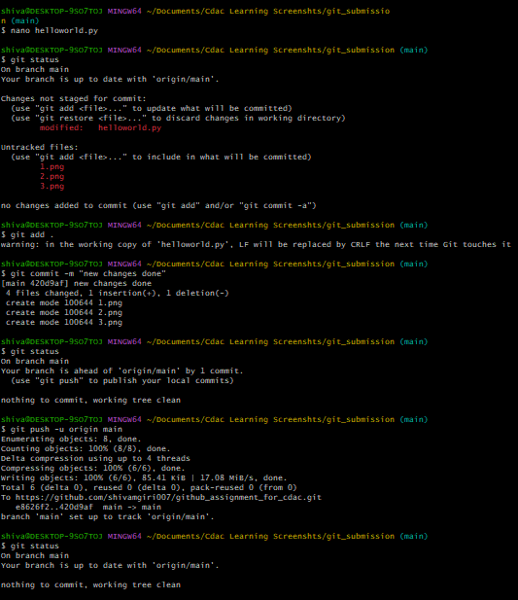

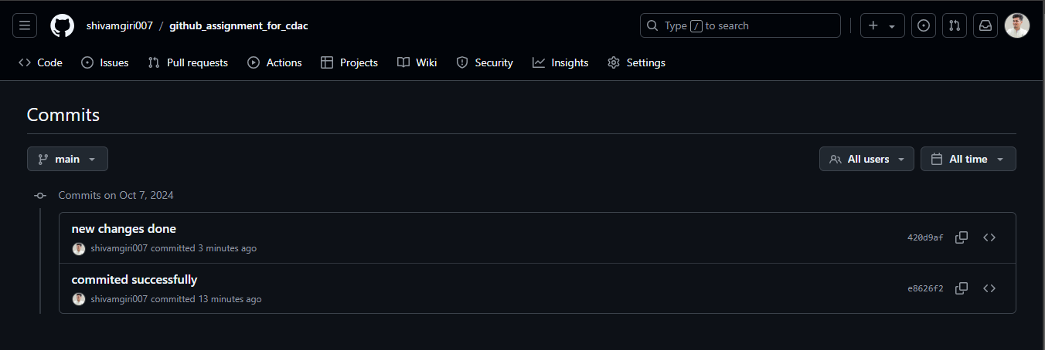

Q. Create g1 branch on the github

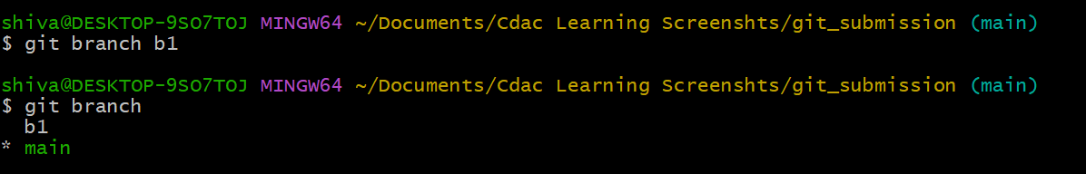



..................Add 1 txt file .................



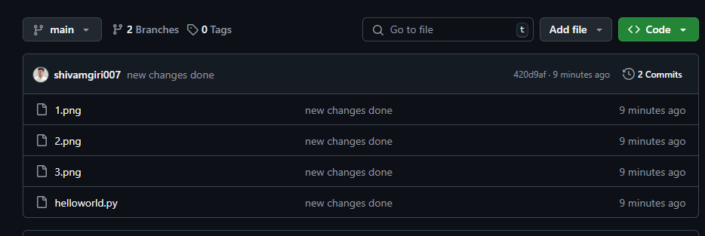

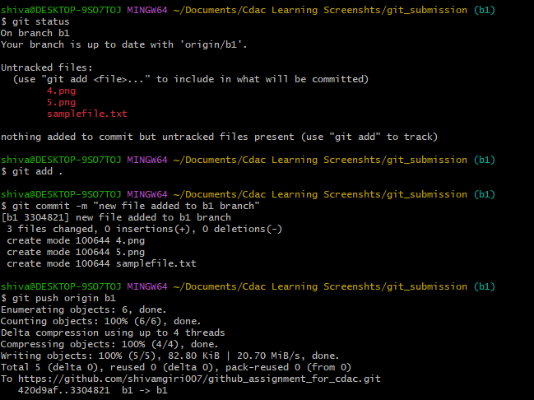

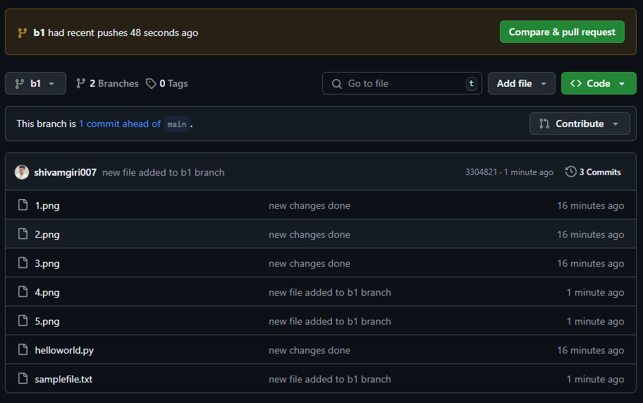

Raise a pull request on remote from g1 towards main........................... and merge without conflicts.

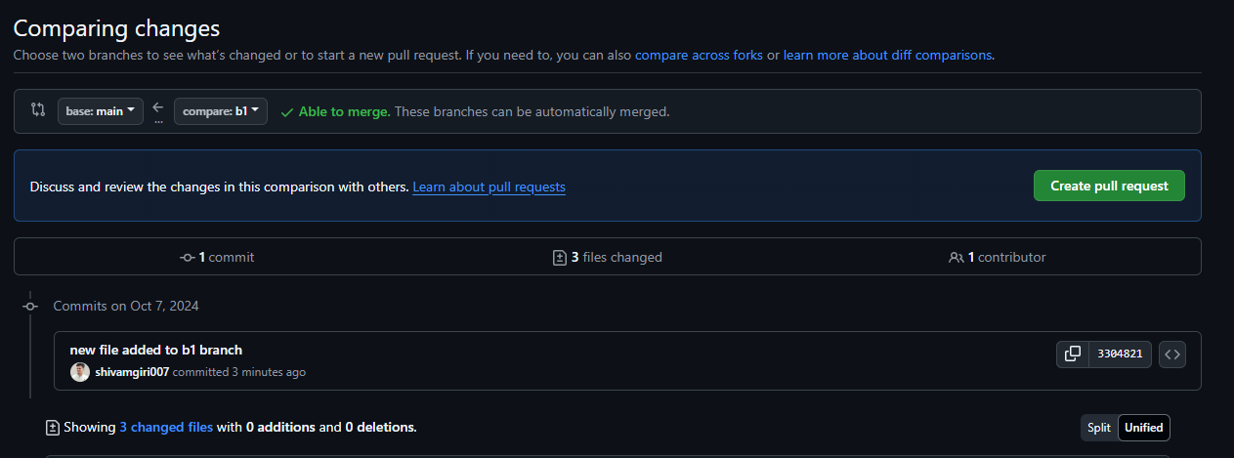

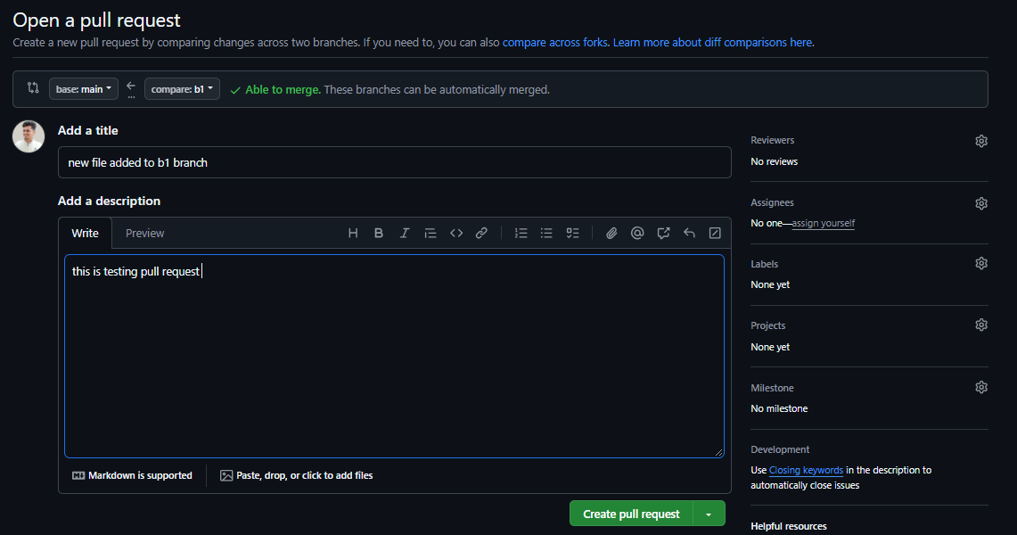

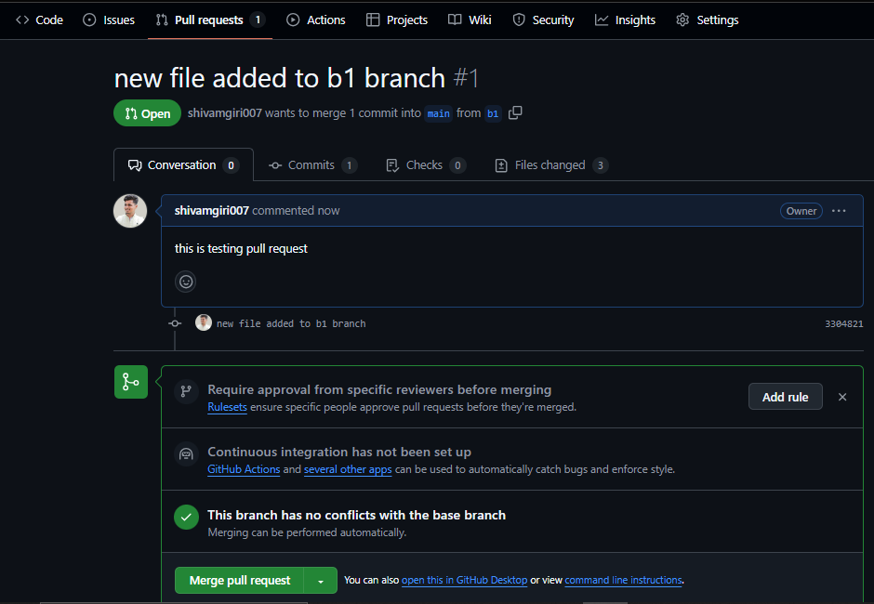

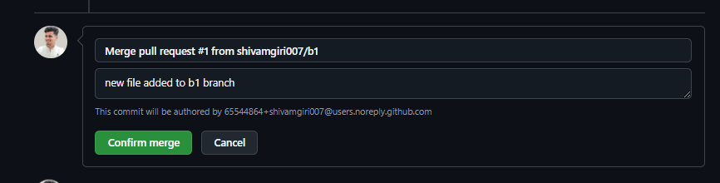  
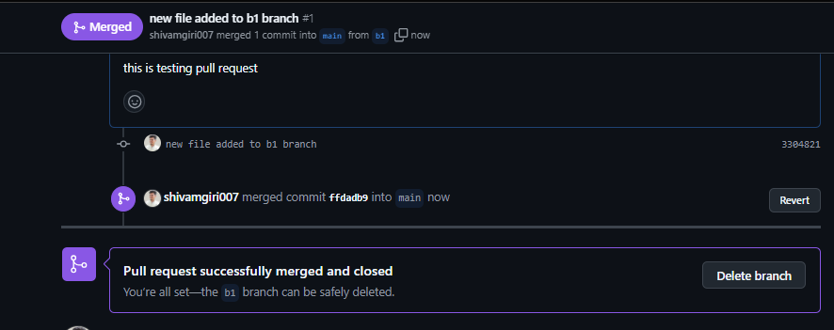

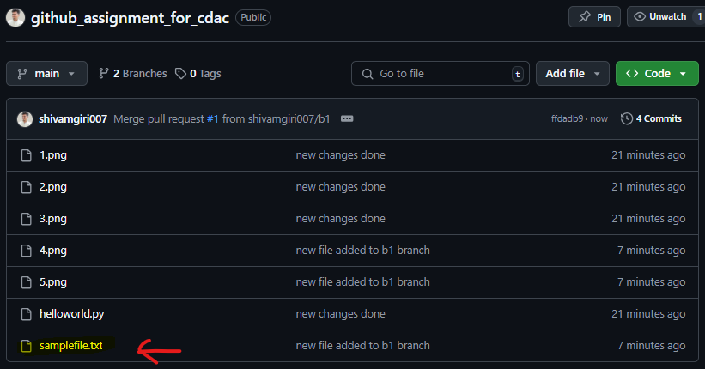

Local git: Use git commands to

o Get the updated files

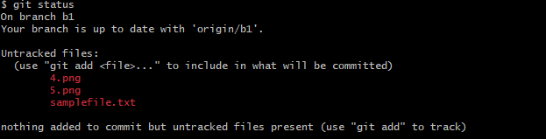

o Perform reset

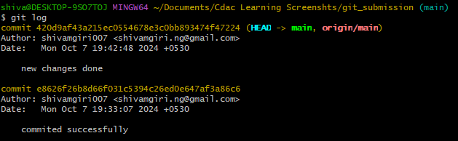

o List the changes

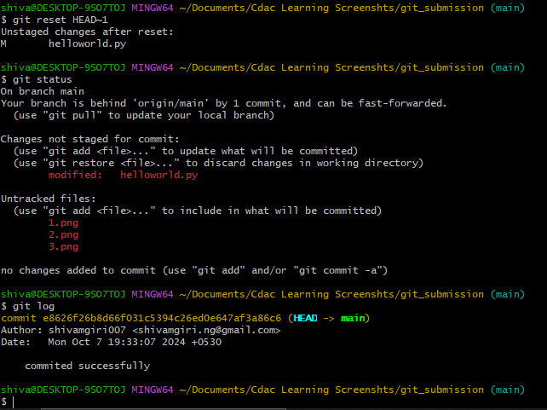

o Create local branches main>>>b1,update........b1>>>>b2,update b2>>>>>b3 and update them as well.

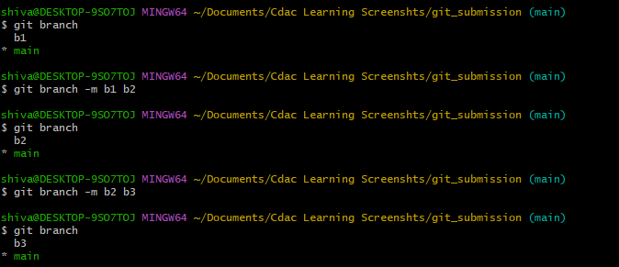

o List the changes [via diff and via ls]

diff

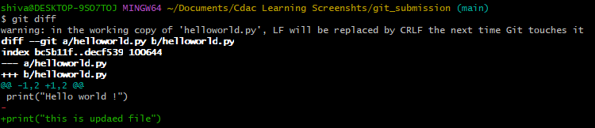

ls

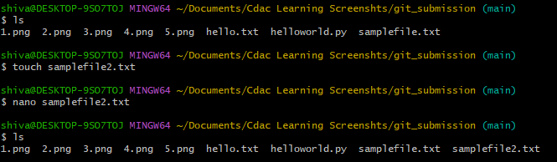

Demonstrate diff between local branches

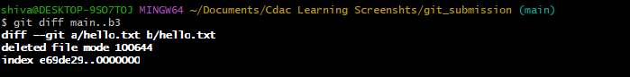

Perform LOCAL merging operation and after that delete the unnecessary ones locally as well as remote

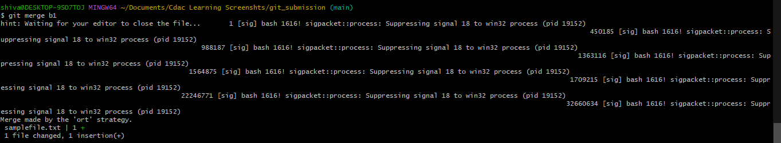

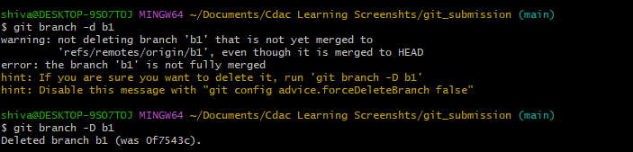



Perform fork operations on your repository as well.

